Voltage Sag/Swell Compensation Using Z-Source Inverter based Dynamic Voltage Restorer

ABSTRACT
The modeling and simulation of a dynamic voltage restorer as a voltage sag/swell mitigation device in electrical power distribution networks is presented in this paper. The dynamic voltage restorer, with its excellent dynamic capabilities, when installed between the supply and a critical load feeder, can compensate for voltage sags/swells, restoring line voltage to its nominal value within few milliseconds and hence avoiding any power disruption to the load. A new topology based on Z-source inverter is presented in order to enhance the voltage restoration property of dynamic voltage restorer. Z-source inverter would ensure a constant DC voltage across the DC-link during the process of voltage compensation. The modeling of Z-source based dynamic voltage restorer is carried out component wise and their performances are analyzed using MATLAB software. The simulation results shows that the control technique is very effective and yields excellent compensation for voltage sag/swell mitigation.
Voltage sag/sell is most important power quality problems challenging the utility industry can be compensated and power is injected into the distribution system. By injecting voltage with a phase advance with respect to the sustained source-side voltage, reactive power can be utilized to help voltage restoration. Dynamic Voltage Restorer, which consists of a set of series and shunt converters connected back-to-back, three series transformers, and a dc capacitor installed on the common dc link. The Pulse-width modulation of Z-source inverter has recently been proposed as an alternative power conversion concept as they have both voltage buck and boost capabilities
In this paper the modeling and control of voltage sag/swell compensation using Z-Source inverter based dynamic voltage restorer are simulated using MATLAB software. The simulation results are presented to show the effectiveness of the proposed control method.

Block diagram for proposed system
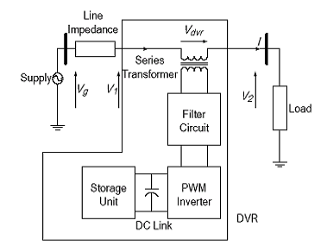
DESIGNG SOFTWARE AND TOOLS:
MATLAB /SIMULATION Software and simpower systems tools are used. Mainly control system tools, power electronics and electrical elements tools are used.

